Project Name: **Sales Performance Analysis**

Solution

1. Use the Saved Sample – Superstore dataset.

Upload Sample-Superstore dataset and drag Order to data model

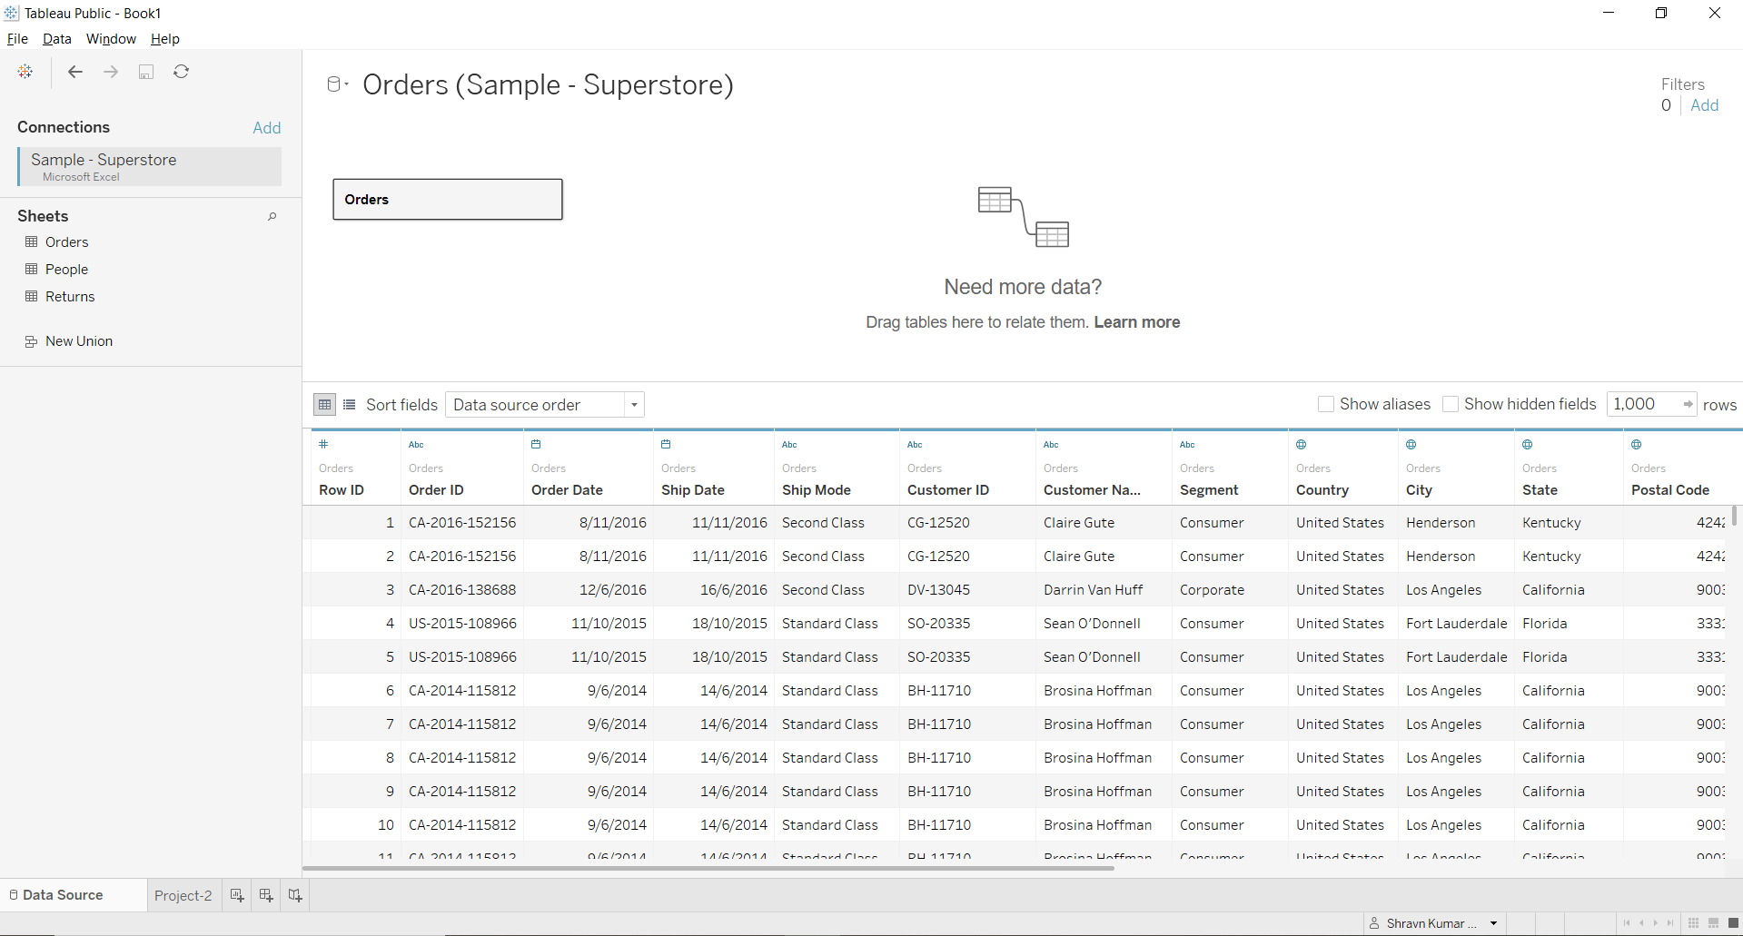

1. Create a bullet chart with Category and Segment dimensions and Sales measures.

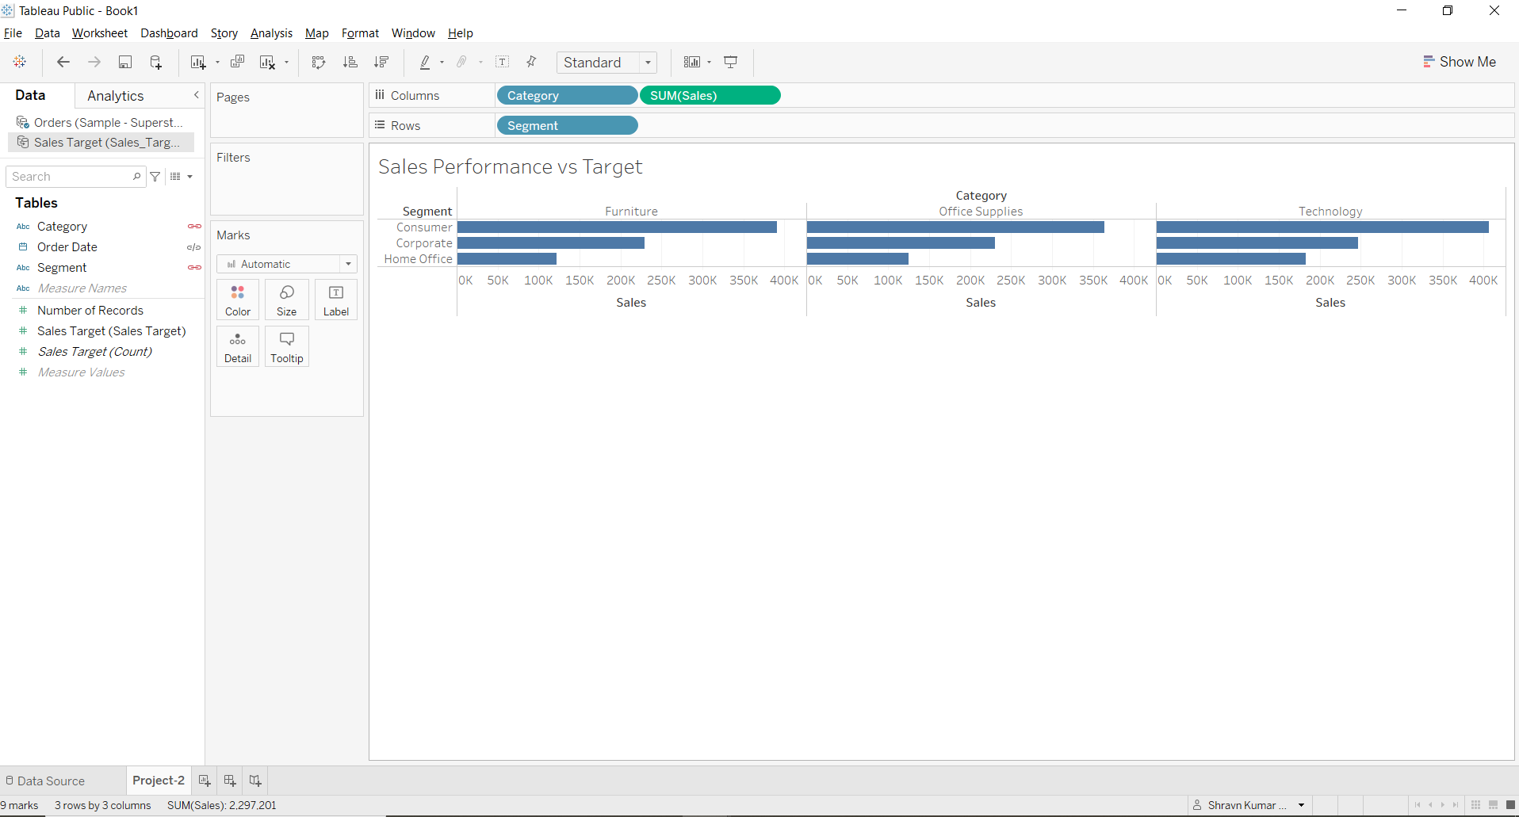

1. Blend the data with the Saved Sample - Sales Target data set to bring in the Sales Target measure. 🡪 Add New Data Source and attach Sales_Target file

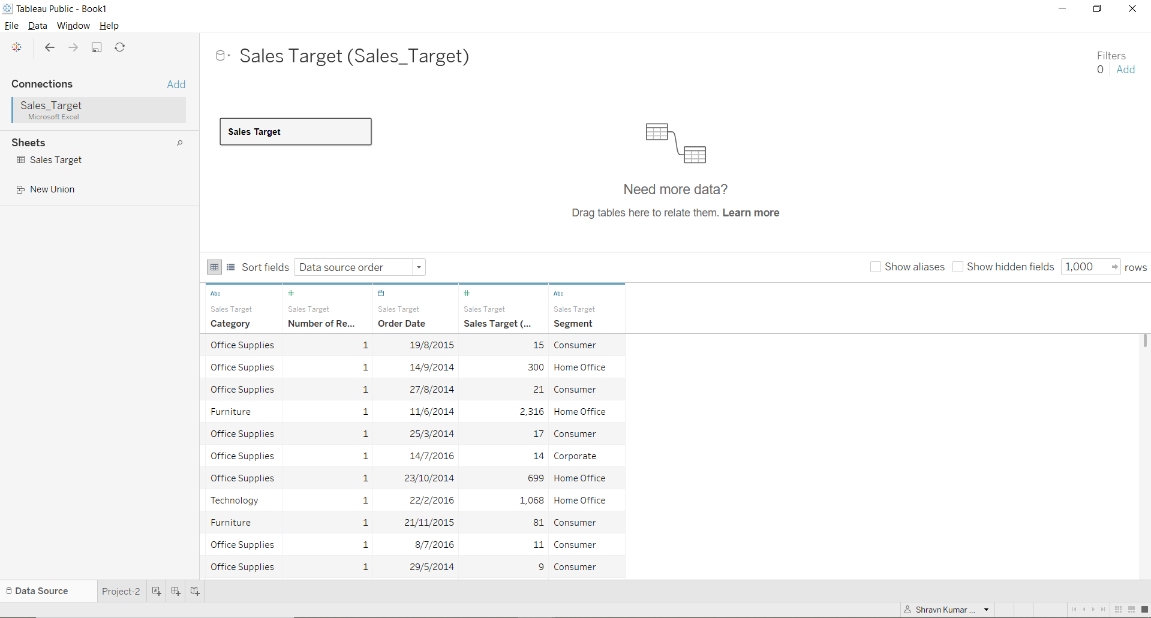

Blend Relationship

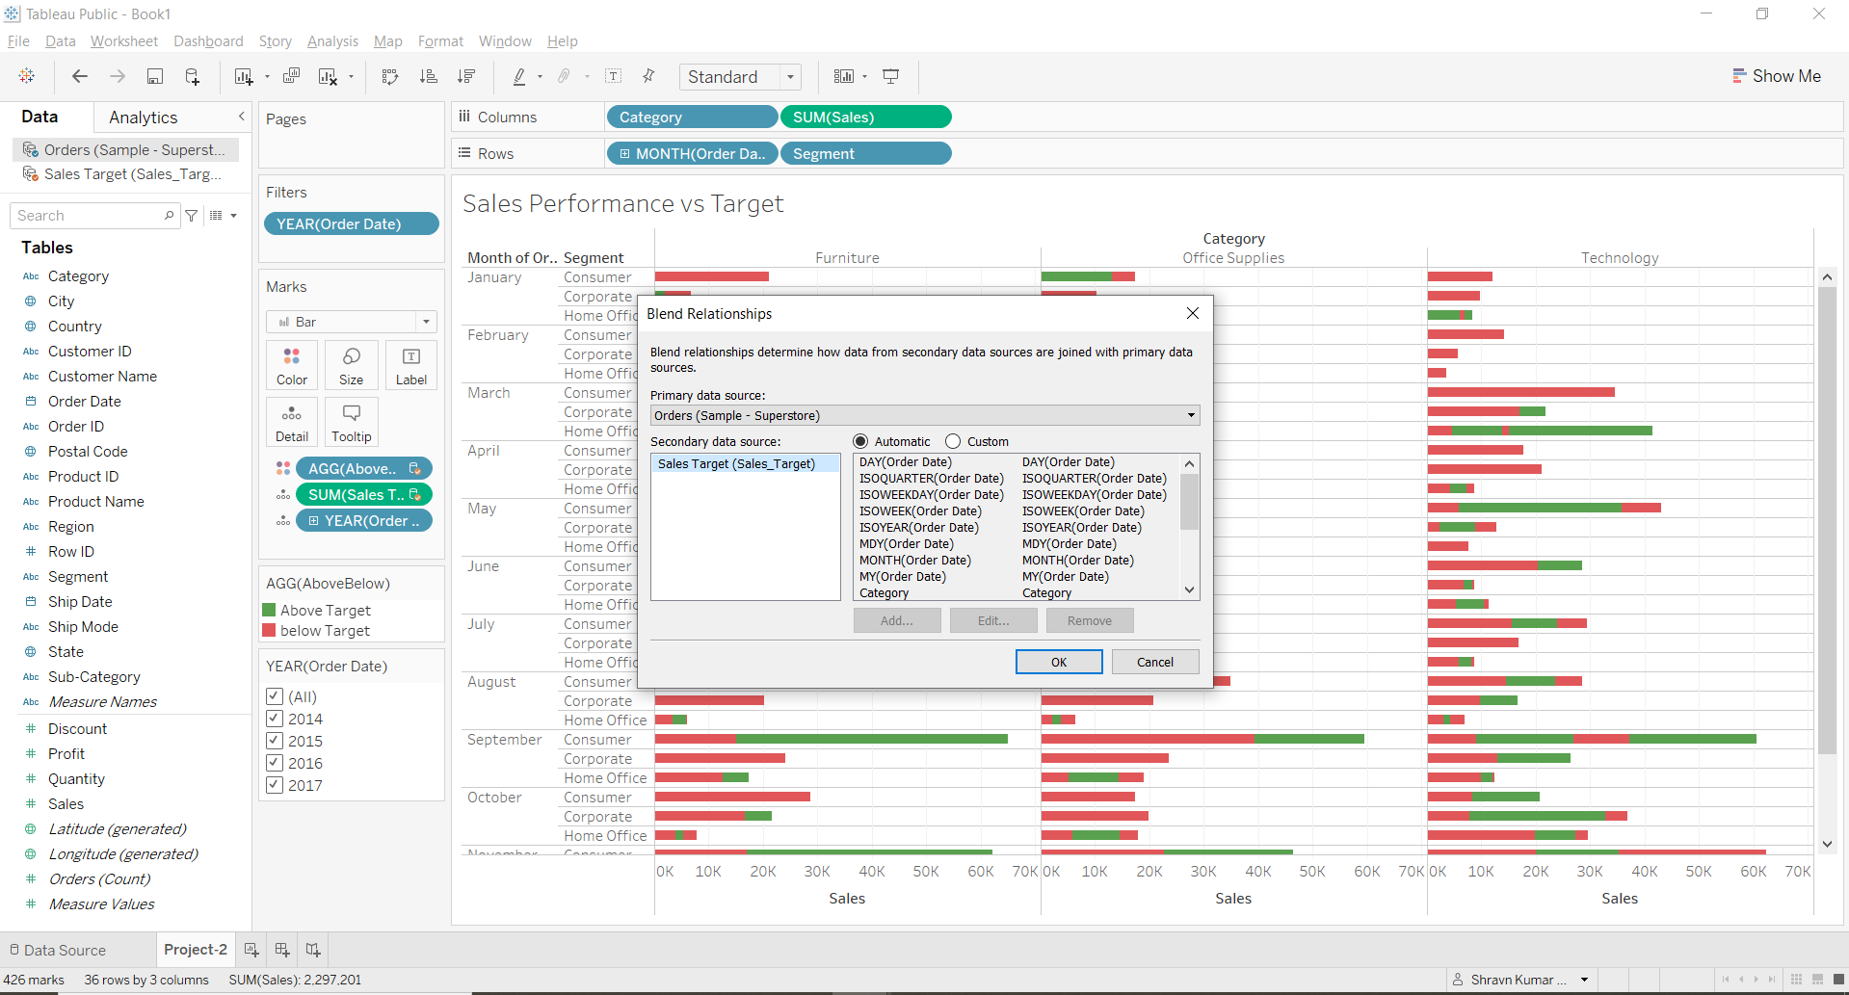

1. Color code the chart to identify Categories and Segments that are above or below target.

* Create a Calculated field to identify Above or below target

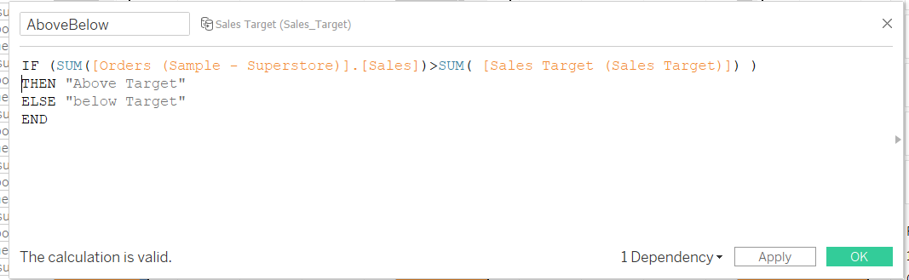

1. Add the year of sales to the view to identify trends and outliers.

* Add Reference Line for sales target

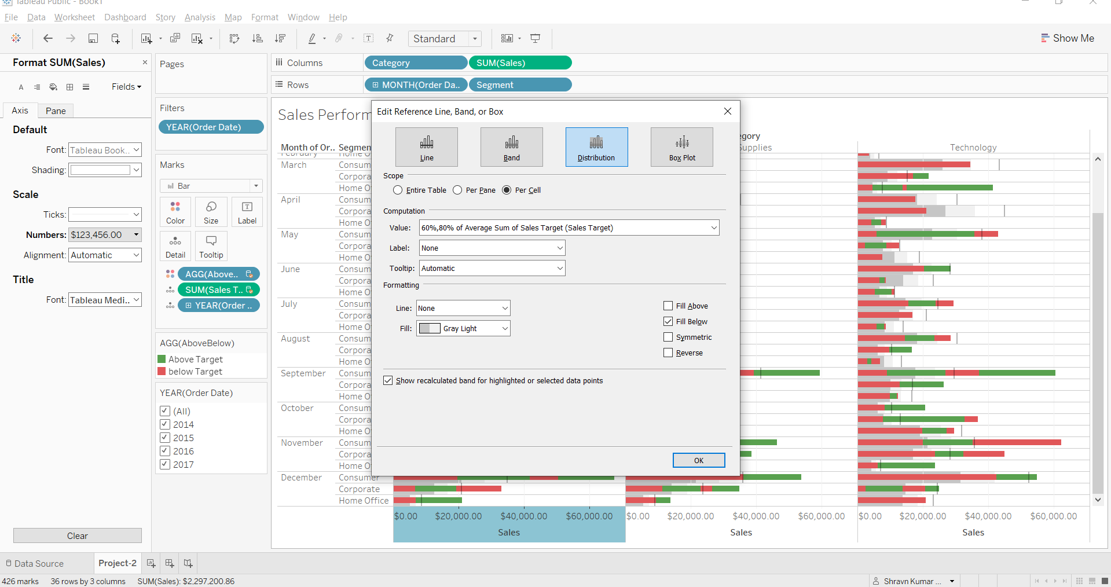

Add reference Line for Average Sales target

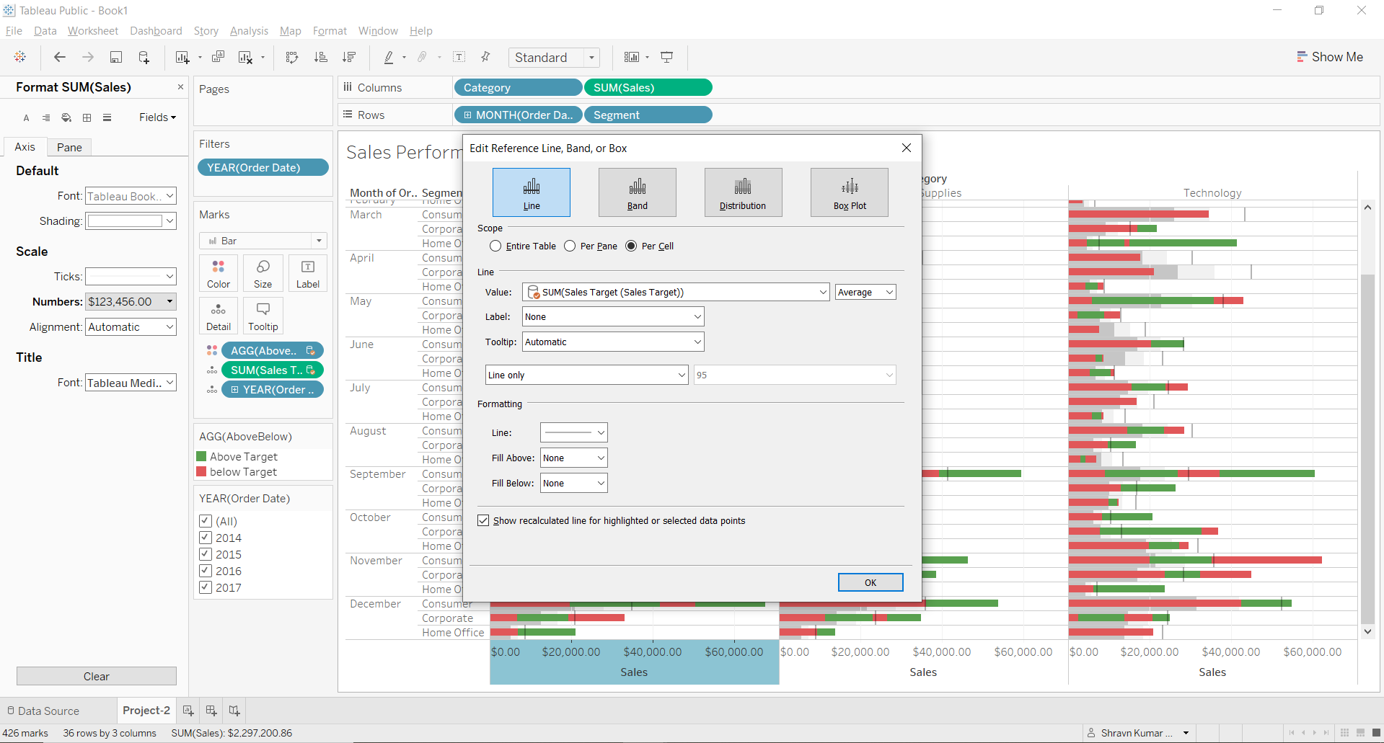

1. Add a filter so that the user can select one, more than one, or all years.

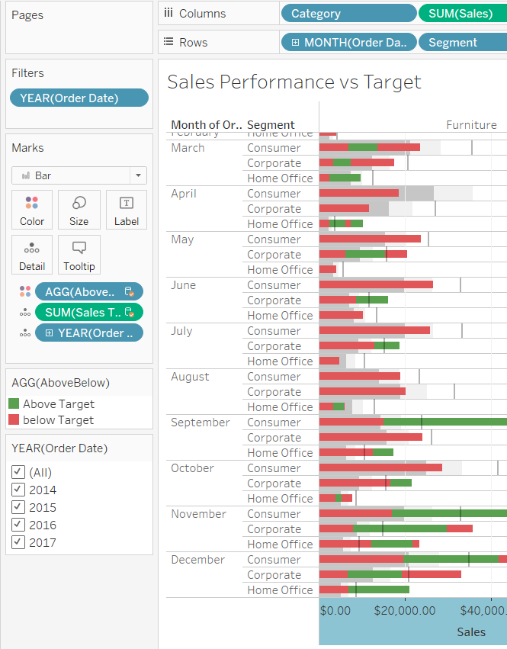

1. Create a dashboard with this view.

